ADITHYA R
192311369

15. Create a Snapshot of a VM and Test it by loading the Previous Version/Cloned VM using Vmware workstation.
AIM: To create a snapshot of a Virtual Machine (VM) using VMware Workstation and verify its functionality by reverting to the previous version or cloned state of the VM.
PROCEDURE:
*Open VMware Workstation and power on the required Virtual Machine.
*Ensure the VM is in a stable working condition before creating the snapshot.
*From the top menu, click VM → Snapshot → Take Snapshot.
*Enter a snapshot name and description, then click Take Snapshot.
*Make changes to the VM (such as installing software, changing settings, or deleting files).
*To load the previous version, go to VM → Snapshot → Snapshot Manager.
*Select the required snapshot and click Go To to revert the VM to its earlier state.
*Alternatively, clone the VM using VM → Manage → Clone, choose the snapshot, and complete the cloning process.
*Power on the reverted or cloned VM and verify that it matches the snapshot state.

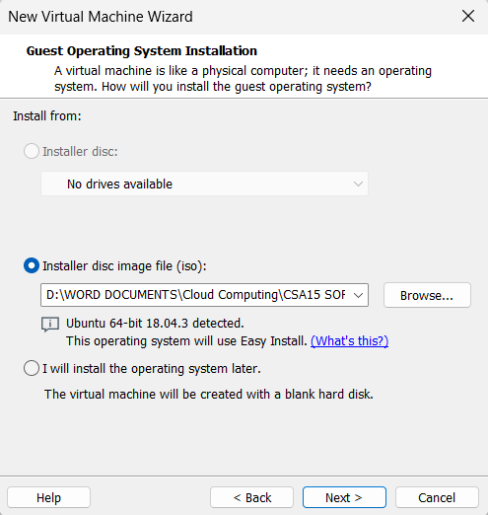

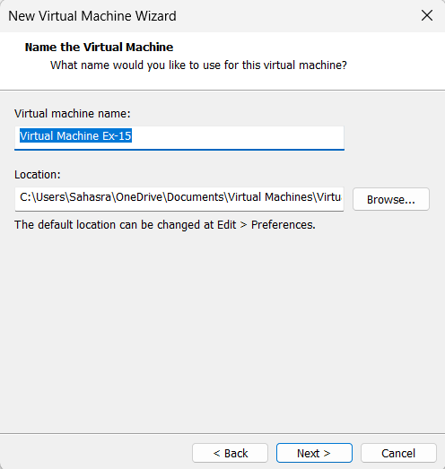

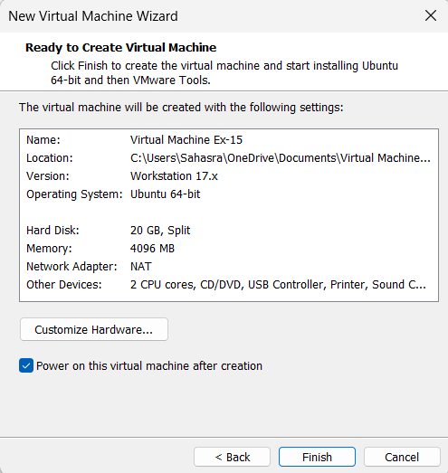

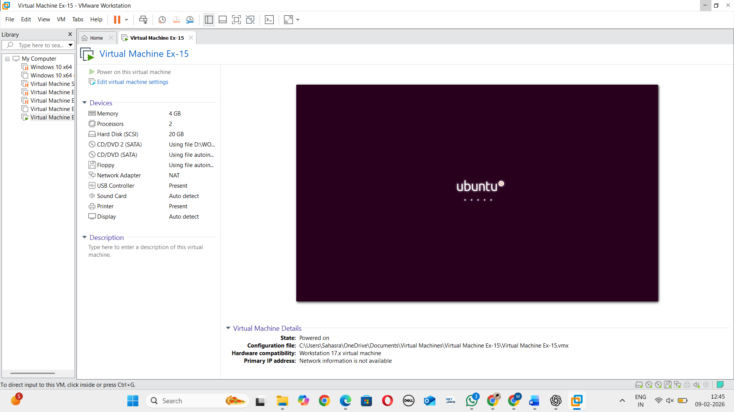

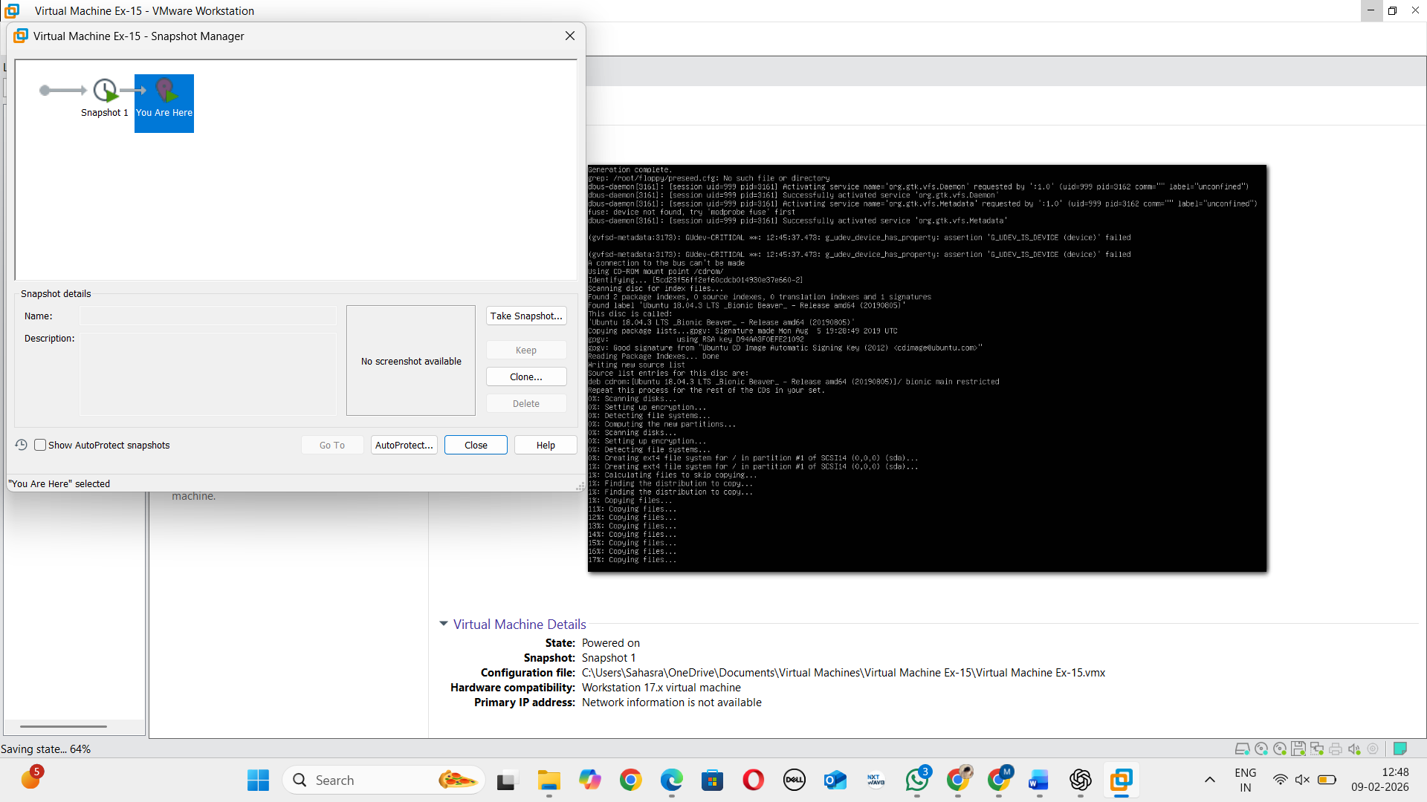
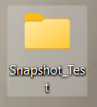

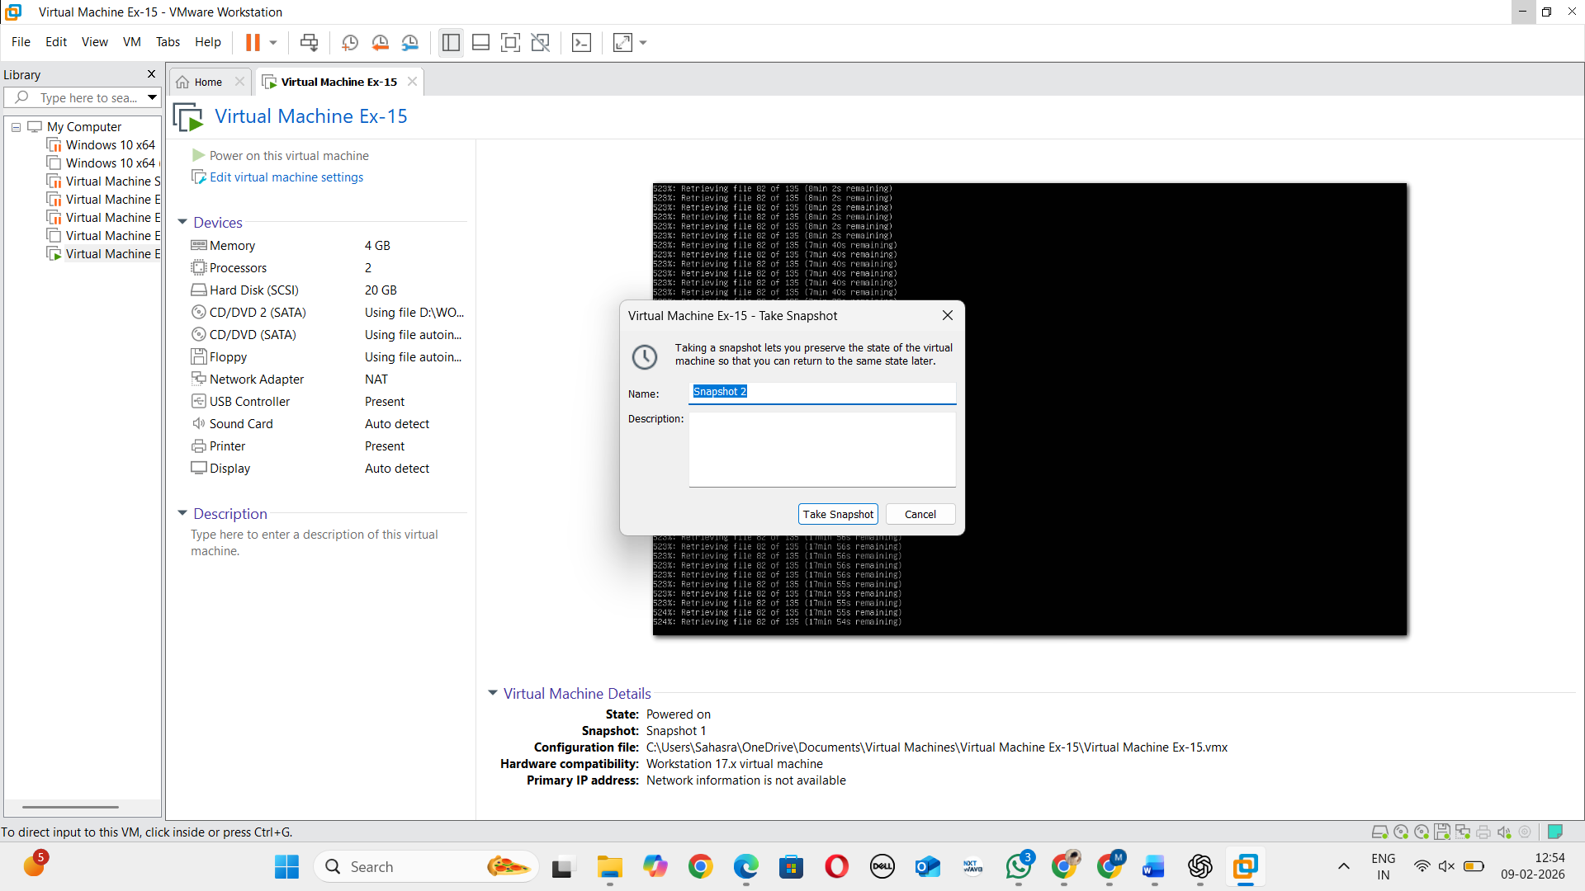

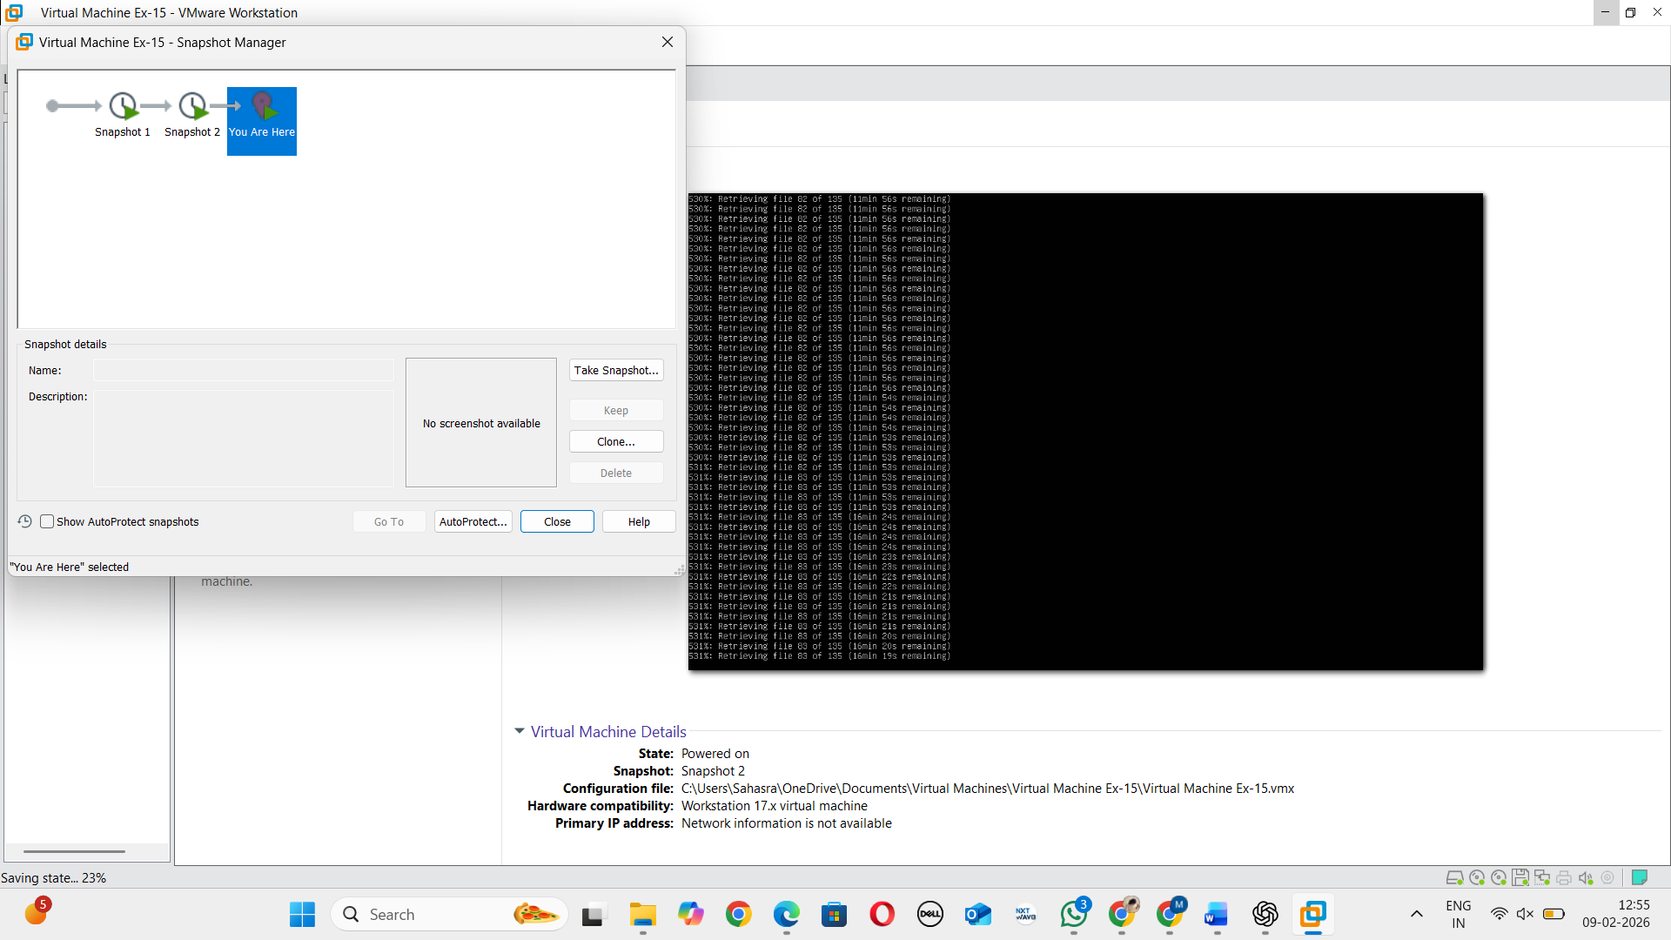

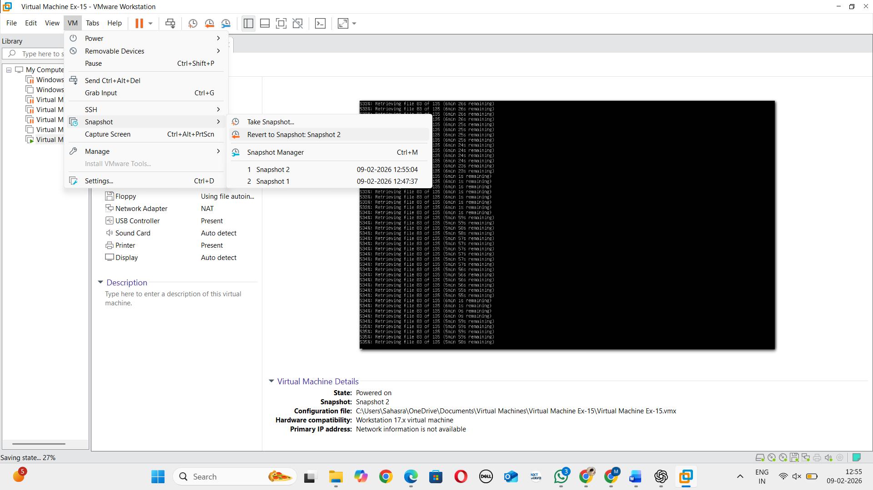
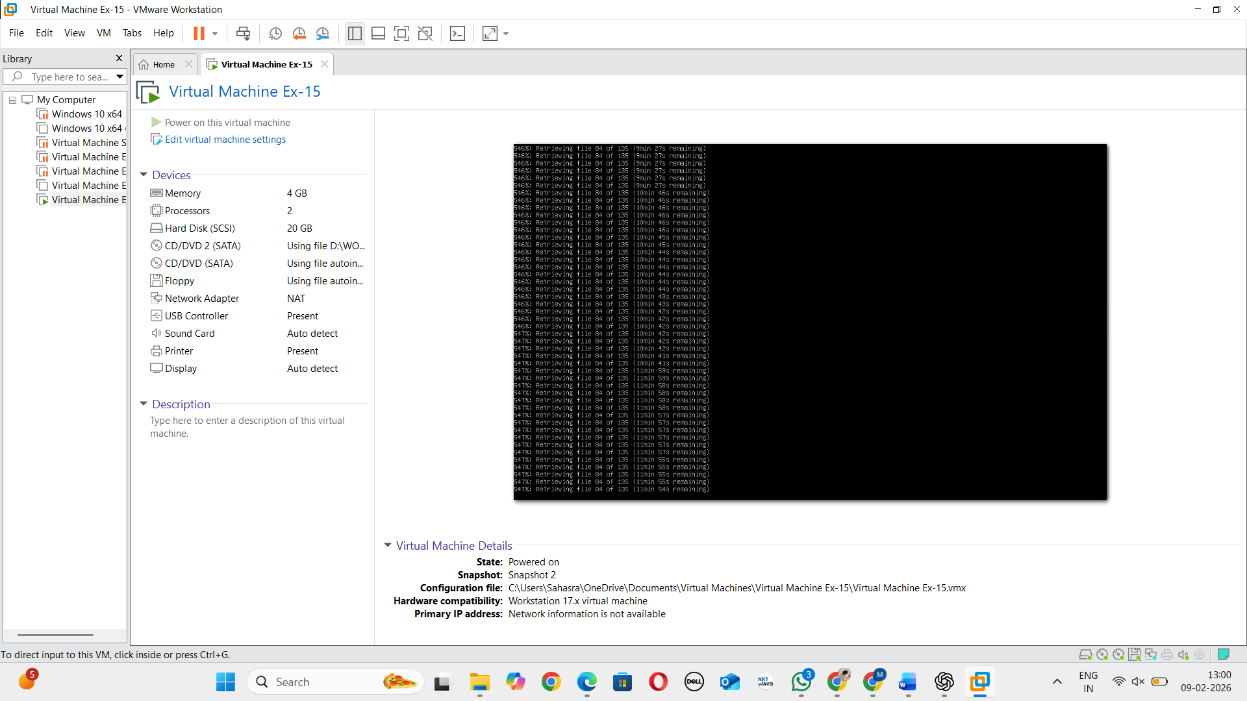

RESULT:
The snapshot of the Virtual Machine was successfully created using VMware Workstation. After making changes, the VM was reverted to the previous snapshot version and also tested using a cloned VM. The system correctly restored the earlier state, confirming that snapshot and recovery operations functioned as expected..

